WITH CLAUSE (CTE)
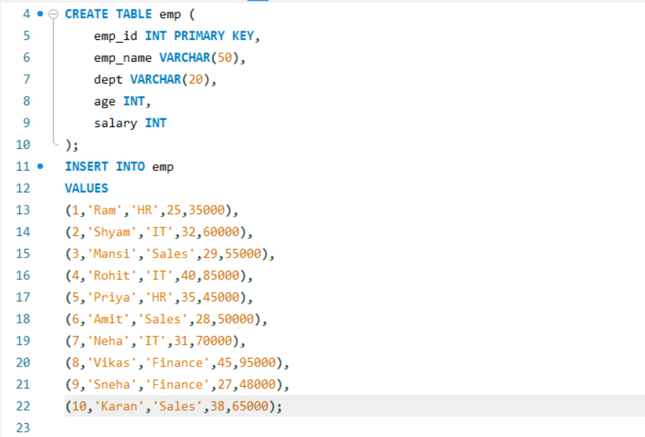



What is a CTE?
- A CTE (Common Table Expression) is a temporary named result set created using the WITH clause.
- It helps break complex queries into smaller and more readable parts.
- A CTE exists only during the execution of the query.
- It can be referenced like a table within the same query.

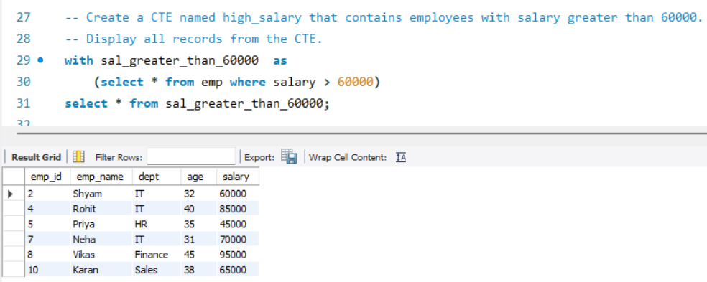

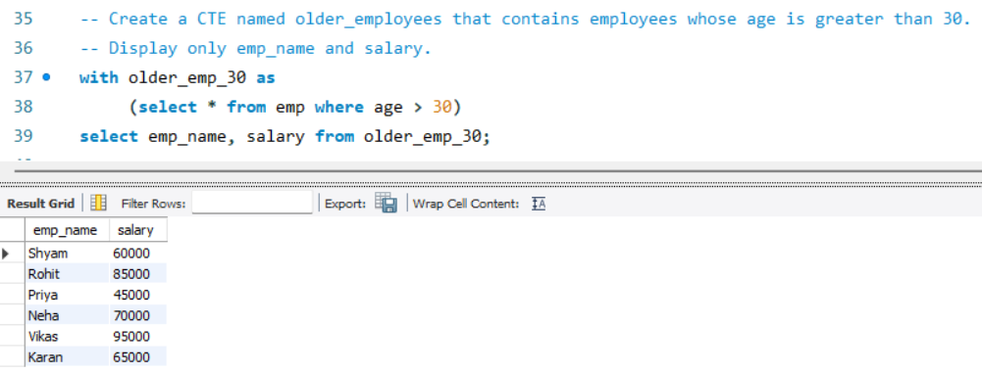

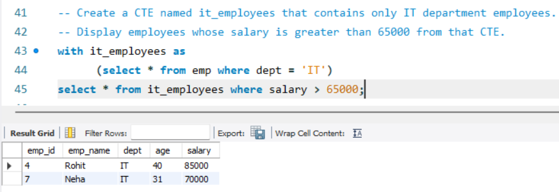

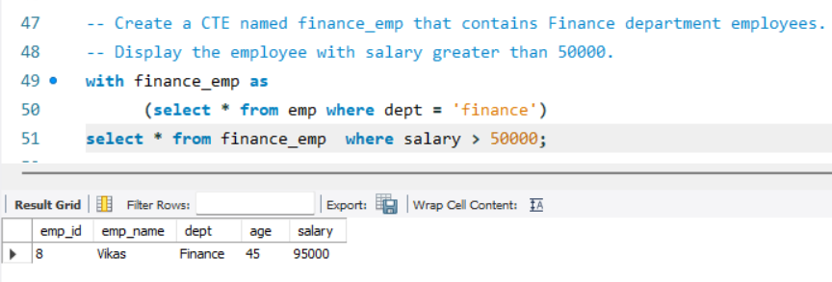

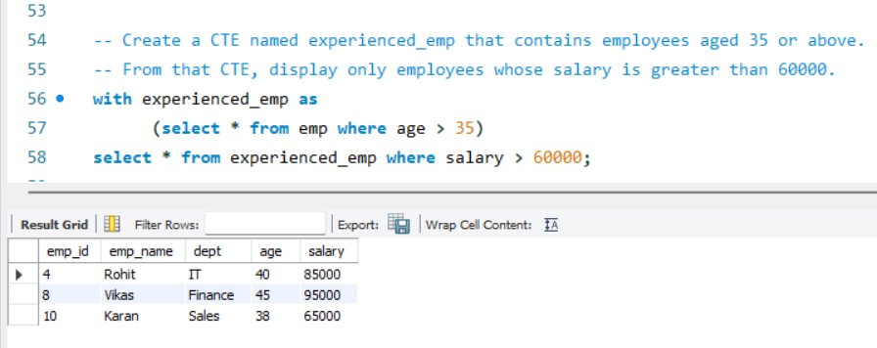

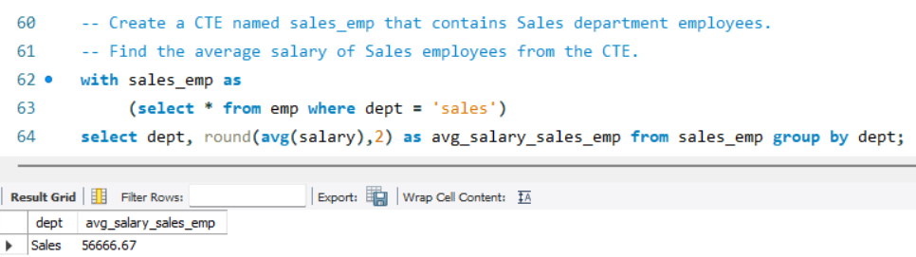

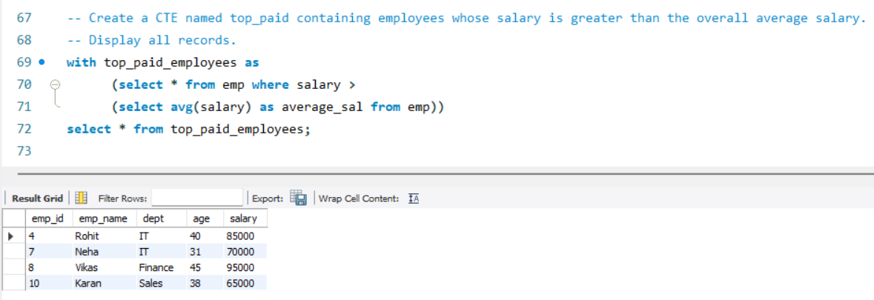

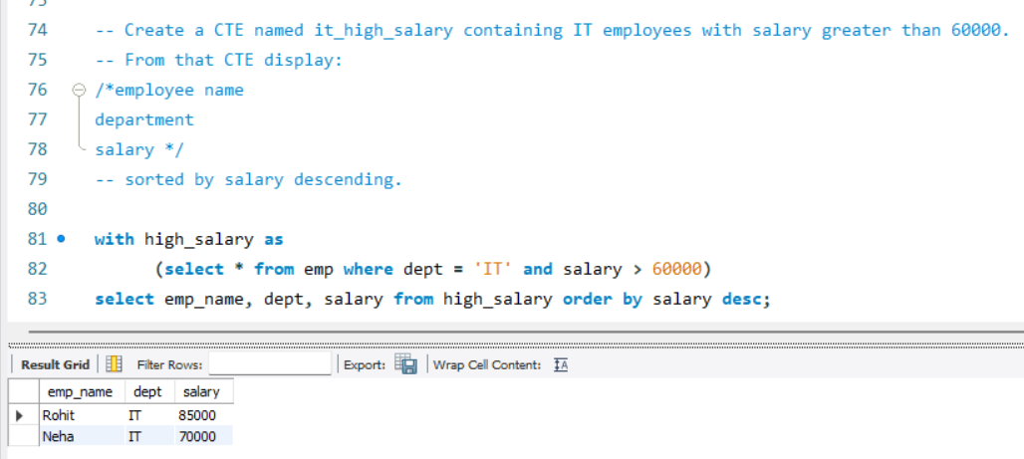

Benefits of CTE
- Improves query readability.
- Makes complex SQL easier to understand.
- Reduces the need for deeply nested subqueries.
- Useful for data transformation and analysis tasks.
- Can be used with recursive queries.
Case Statement

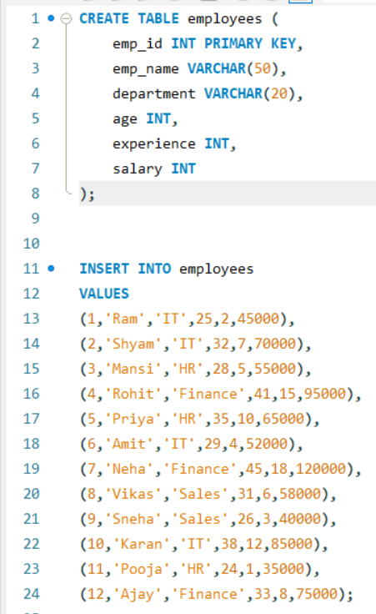

What is a CASE Statement?
- The CASE statement is used to apply conditional logic in SQL.
- It works similarly to IF-ELSE statements in programming languages.
- It returns different values based on specified conditions.
- Commonly used for categorization, labeling, and conditional calculations.

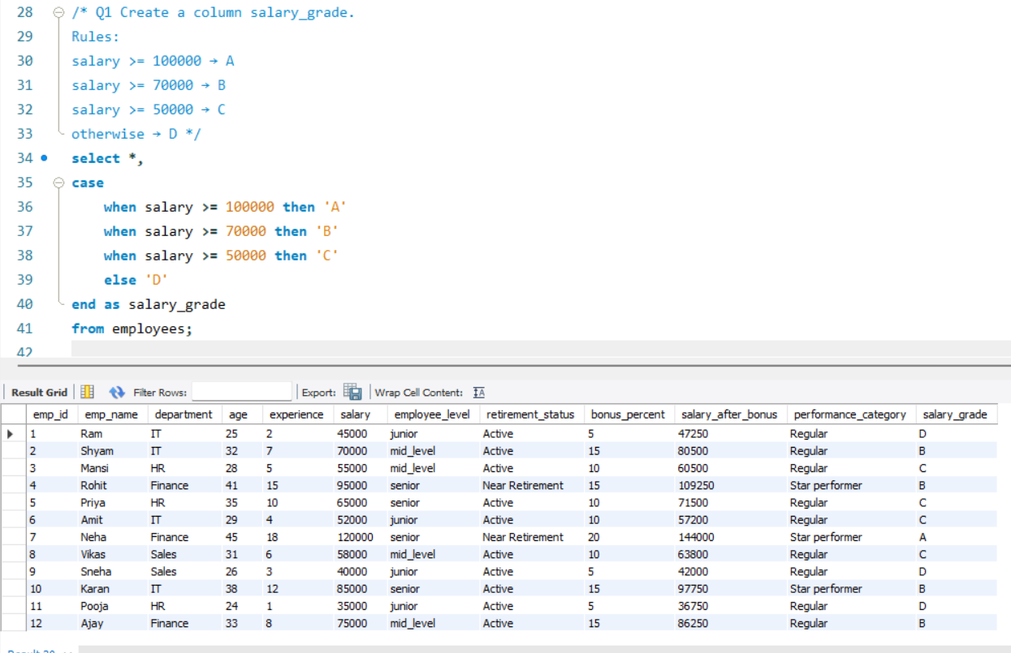

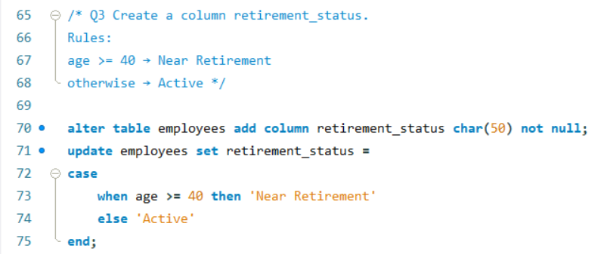
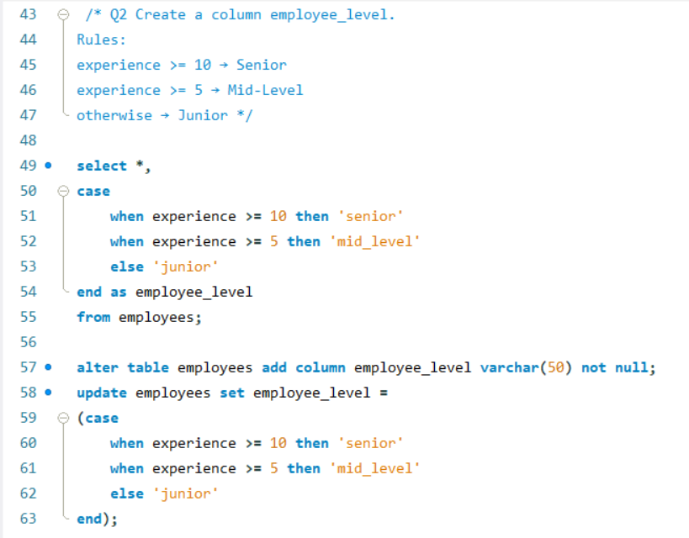

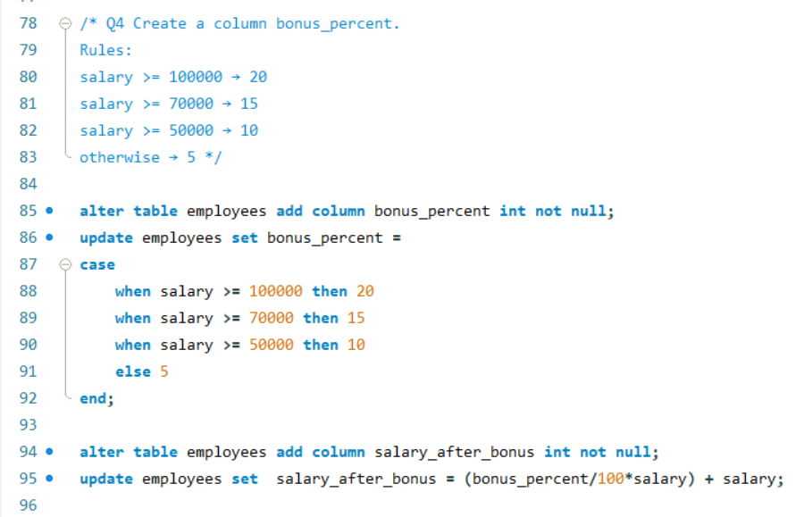

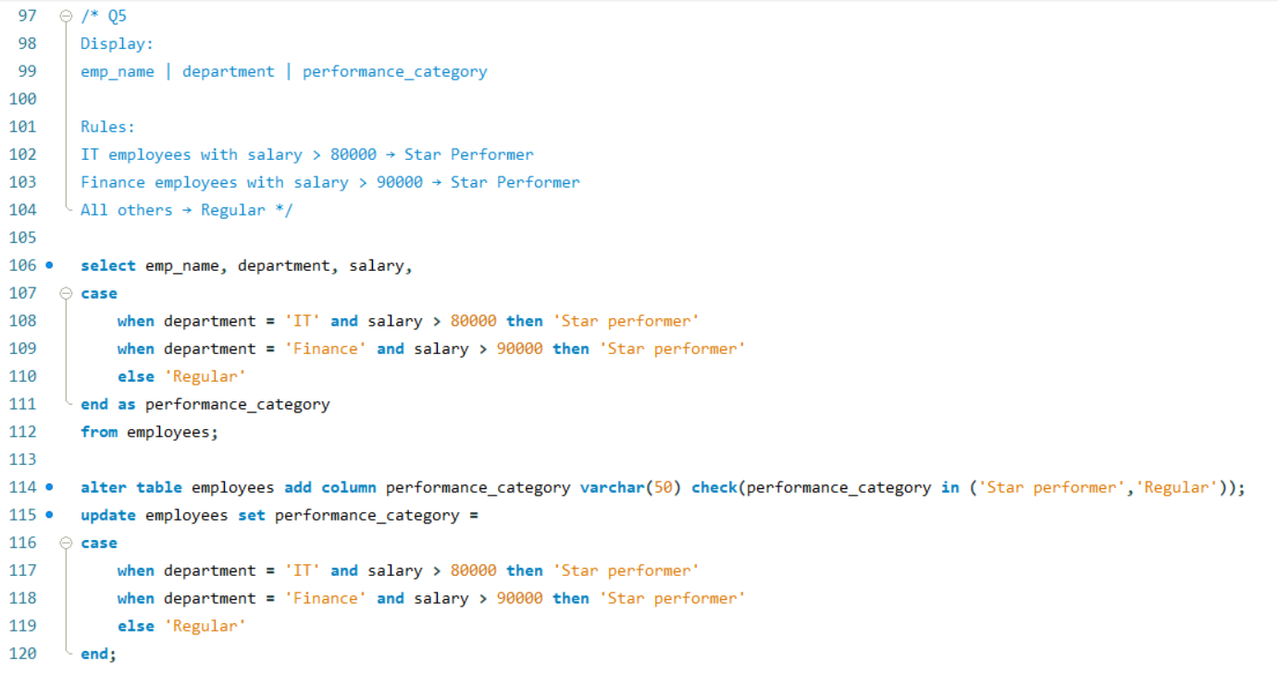
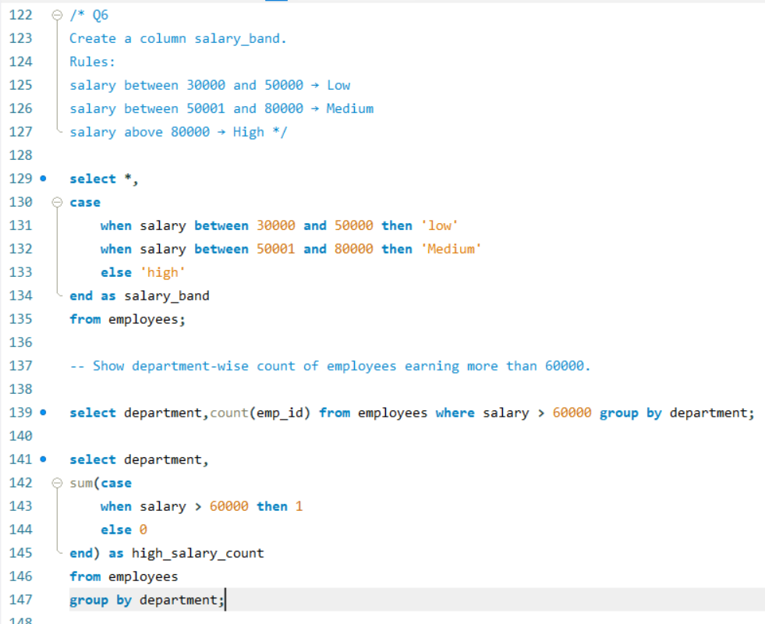

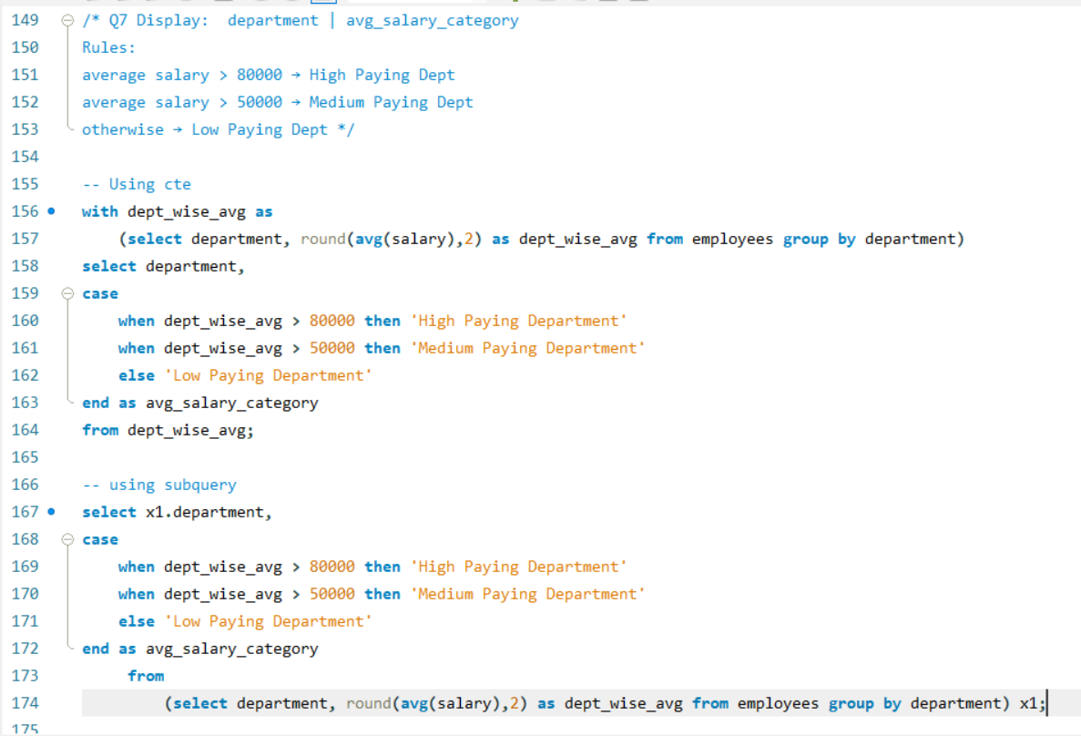

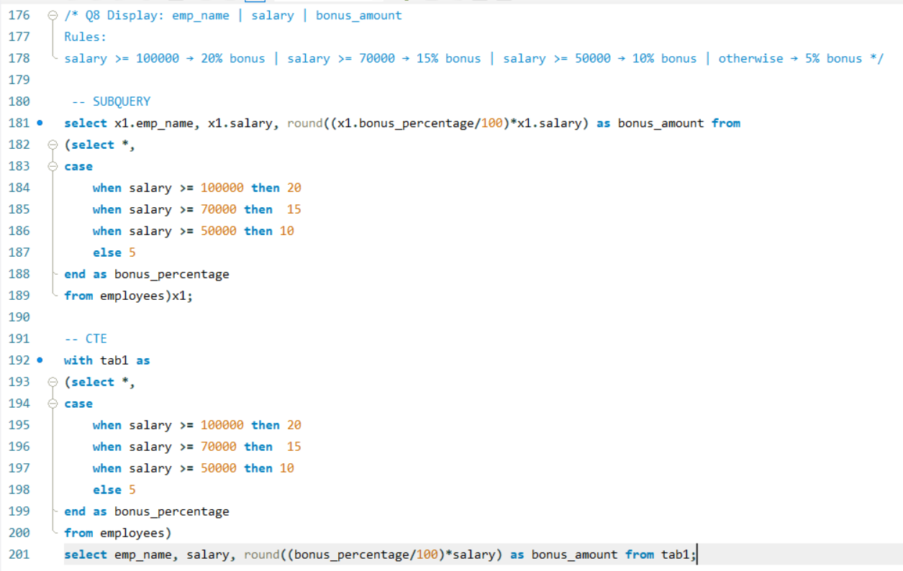

Benefits of CASE
- Simplifies conditional logic in queries.
- Creates custom categories and classifications.
- Useful for reporting and dashboard development.
- Can be combined with aggregate functions such as SUM(), COUNT(), and AVG().

Key Learnings
- Created and used Common Table Expressions (CTEs).
- Compared CTEs with subqueries.
- Implemented conditional logic using CASE statements.
- Built employee categorization and salary grading logic.
- Used CASE with aggregate functions for conditional aggregation.
- Improved query readability and maintainability.
- Practiced real-world SQL scenarios commonly used in data analytics.

